|  |
| --- |
| Meshreq |
| Find On Business Requirements Analysis and Specifications Description |
| Version 2 | Jan-18 |

|  |
| --- |
|  |

Contents

1. Document overview 4

1.1. Introduction 4

1.2. Document purpose 4

1.3. Audience 4

1.4. Notes 4

2. Requirement Overview 5

2.1. Introduction 5

3. Modules 6

3.1 Selection for actions 6

3.1.1 Overview 6

3.1.2 Functionalities 6

3.1.3 Rules 6

3.2 Business card request functionality 6

3.2.1 Overview 6

3.2.2 Functionalities 6

3.2.3 Rules 6

3.3 Find On packages limitations and payments 6

3.3.1 Overview 6

3.3.2 Functionalities 6

3.3.3 Rules 6

3.4 Sending SMS – Users Module 7

3.4.1 Overview 7

3.4.2 Functionalities 7

3.4.3 Rules 7

3.4.4 Future work 7

3.5 Sending SMS – Staff Module 7

3.5.1 Overview 7

3.5.2 Functionalities 7

3.5.3 Future work 7

3.6 Sending Emails 8

3.6.1 Overview 8

3.6.2 Functionalities 8

3.6.3 Rules 8

3.6.4 Future work 8

4 Appendix 8

4.1 Wireframes 8

4.1.1 Business cards selection 8

4.1.2 Card Request dialogue 9

4.1.3 Requests notifications 9

4.1.4 Request page: sent 9

4.1.5 Request page: received 10

4.1.6 Send SMS dialogue 10

4.1.7 SMS management: Statistics 11

4.1.8 SMS management: buy 11

4.1.9 SMS management: settings 12

5 Business Requirements Sign off 12

# Document overview

## Introduction

As per agreement between Edex and Meshreq Computer Systems, Meshreq is implementing “Find On” a contact management system for Edex. Phase 1 including core functionalities is being developed. While new business needs appeared for Edex to enhance business functionality for Find On.

As a part of Meshreq responsibilities this document comes with the business analysis for Edex requirements about the new required functionalities.

## Document purpose

* Defining and analyzing Edex requirement about Find On

## Audience

* Edex business team
* Meshreq technical team

## Notes

All data within this document and related documents are considered as confidential data and not allowed to be share without a signed agreement from both parties.

# Requirement Overview



## Introduction

Find On is aimed to enhance business engagement activities, explore opportunities and leverage business reputation. An application introduced in the form of hosted service derived by users’ subscriptions.

The app gives users capabilities to handle and manage their business cards and contacts in efficient way through three steps. First is data entry which is handled in multiple ways to give user the ease of data entry. Second is data processing and manipulation; user can perform his business operations like searching, sorting, eliminating duplicates, finding new contacts and so on. Third is retrieving or exporting data in a many formats to support various customer needs.

Service is provided in the form of plans or subscriptions for persons and corporates.

# Modules



## Selection for actions

### Overview

Selection functionality is suggested to improve usability for users. Where user can filter business cards then selects only the cards he wants. Then actions can be performed on this selected set.

Actions are defined in other modules, for example user can send SMS to the selected users.

### Functionalities

1. Check box on business cards to select/deselect a single business card
2. “Selected all” button to select all the filtered cards
3. “Select none” button to deselect all
4. Counter to count the number of selected business cards
5. On selection, the business card is marked and colored as selected

### Rules

1. Find On business cards cannot be selected
2. If user refreshed the page selected cards don’t change
3. When user makes an action on selected cards, permissions are applied for every card before applying the action to it

## Business card request functionality

### Overview

When a user registers the application creates a business card for him which he can modify later and complete its fields. This type of card are called “Find On” cards, they are the cards owned by Find On. Users can search within these cards to find contacts in Find On cards.

For privacy, Find On cards show only name, title and personal photo. So for a user to get full details he has to send a request to the card owner who can accept or deny.

### Functionalities

1. User can set his privacy level from a form
2. User (sender) can send card request if the card data is not shown and this request is received at the card owner (receiver)
3. Sender can view his sent requests and its states in a form
4. Receiver can view his received requests in a form
5. On every action when receiver receives a request he is notified
6. When receiver make action on request, sender is notified (action are read, confirm and ignore)
7. Notifications are by:
   1. Mail
   2. Notification bar: where icon in user bar is for requests notifications, this icon has counter to count unread notifications and opens the requests form on click. This counter is updated without page refresh (**push protocol**).
8. When request is sent, sender business card is added automatically to receiver’s contacts (by default to personal)
9. When receiver denies the request nothing happens
10. When receiver accepts the request receiver’s card is added automatically to sender’s contacts (by default to personal)
11. Requests page is the page carrying all requests data either send or receive

### Rules

1. Find On cards show only name, title and avatar
2. User has 3 privacy levels
   1. Level 1: public: where all card data are shown on search
   2. Level 2: secret: where his business card is not shown during search
   3. Level 3: with request: full card is shown only upon his approval, and this is the default setting

## Find On packages limitations and payments

### Overview

Find On have different packages free or premium. User can purchase any package which suits his needs. User is taken to payment page where payment process is performed then this payment is reflected on the service inside the system.

### Functionalities

1. User can purchase any personal package from personal subscription page (personal packages free and pro). Or he can purchase corporate subscriptions from corporate subscription page
2. Renewals are from the pages
3. Renewal dates are mentioned on the subscription summary page
4. Payment is performed through a redirection to payment gateway service
5. A scheduled job runs every day to:
   1. Suspend accounts with ended due dates and send email to suspended accounts
   2. Send notifications to accounts with renewals in less than a week and didn’t renew yet
6. Access control is given for actions depending on subscription limitations
7. Scalability limits validations are applied according subscription limitations
8. The following tables mentions the subscriptions differentiations:
9. Subscription periods are:
   1. Monthly
   2. Annually
10. Staff users can change subscriptions data (end and start dates, status)
11. Staff users can update personal subscriptions or add corporate subscription

### Rules

1. When subscription period ends his account is closed and his data is kept for a period (configurable period). If he didn’t renew during this period his data is cleaned and can’t be recovered

## Sending SMS – Users Module

### Overview

Sending SMS is a competitive edge for Find On where user can simply send SMS to the selected contacts in his contact list. Here user has to buy credit first then he can send. Balance handling is performed before every action.

### Functionalities

1. User can purchase SMSs from a dedicated web form
2. Purchase happens on the fly; user demands a package then pays for the package then Find On buys the SMS for this user
3. Purchase page includes packages and prices
4. User can purchase any package from the form, where he redirected to a payment page and packages fees is charged on him
5. If payment is successful then user balance is increased with the package amount
6. User can send SMS to the selected card(s) from “user home”
7. On pressing button “send” message box appears to write the SMS message
8. User can view his balance from “user settings” page
9. User sets his “sender name” from user settings
10. User receives notification on mail when he charges his account

### Rules

1. “sender name” must be set before sending
2. If a contact card has multiple mobile numbers SMS will be sent to the first number
3. Before sending any SMS balance check is performed

### Future work

*This part of analysis is suggested for implementation in future phases of the project and not included in price mentioned in the proposal*

1. User can view his sending history
2. For every item in the history user can view report about receiving the message for every receiver
3. User can receive messages if receiver sends a reply to his original SMS

## Sending SMS – Staff Module

### Overview

Staff members have a view to manage and monitor SMS functionality. This monitoring is important to recharge Find On account at the provider and to control any vulnerability in the system.

### Future work

*This part of analysis is suggested for implementation in future phases of the project and not included in price mentioned in the proposal*

1. Staff can view purchase logs of members
2. Staff can manage members balance (credit/debit)
3. Can view sent messages log
4. Can view receivers log
5. Can stop sending SMS function from certain user
6. Can run reconciliation process to compare balance at provider and managed balance
7. Can run reporting on sent SMS, sold SMS and purchased SMS over months

## Sending Emails

### Overview

Sending emails is important functionality for users. Find On gives users the ability to send emails from their own mail server.

### Functionalities

1. User can configure his mail server from “user settings” for outgoing mails
2. “test configuration” button to test the mail server configuration
3. User can send emails for the selected business cards
4. On pressing send mail composer appears (rich text editor) for the user to compose his message

### Rules

1. User cannot use send email unless he sets his mail server

### Future work

*This part of analysis is suggested for implementation in future phases of the project and not included in price mentioned in the proposal*

1. User can view his sent log

# Appendix

## Wireframes

Following is the wire frames covering the proposed functionalities

### Business cards selection

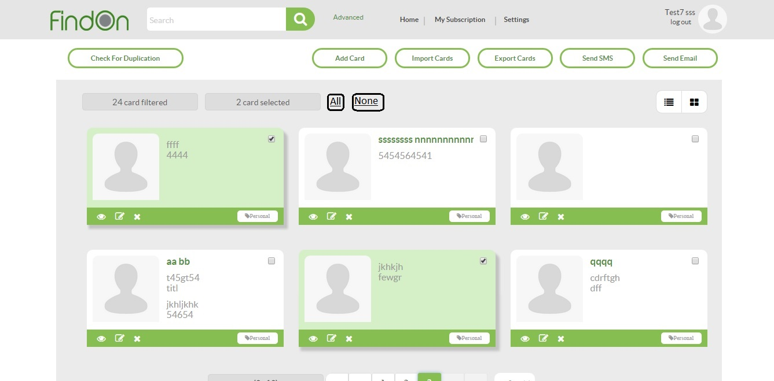

### Card Request dialogue

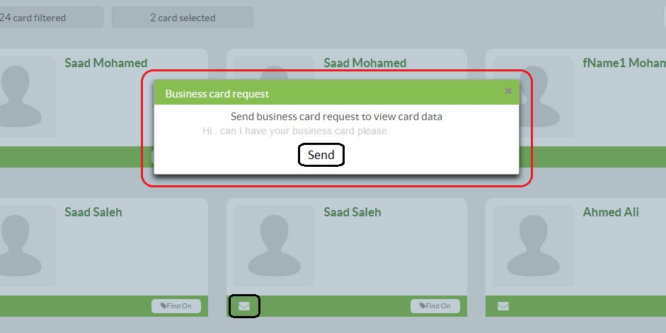

### Requests notifications

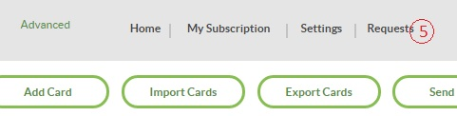

### Request page: sent

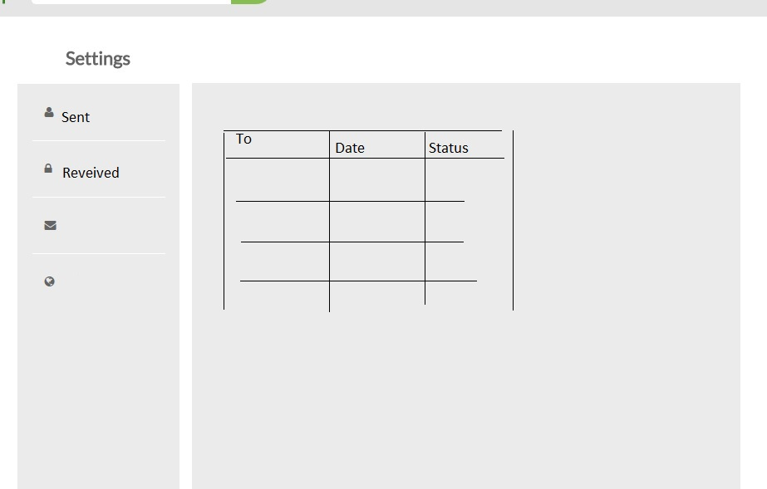

### Request page: received

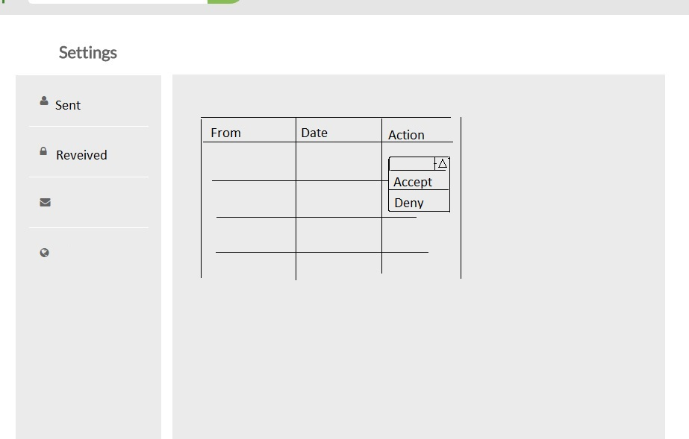

### Send SMS dialogue

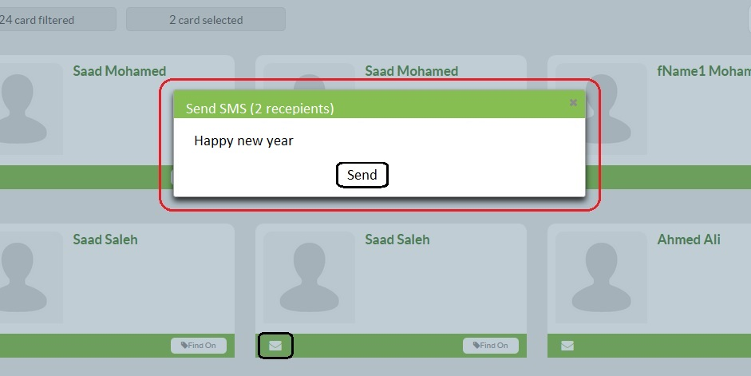

### SMS management: Statistics

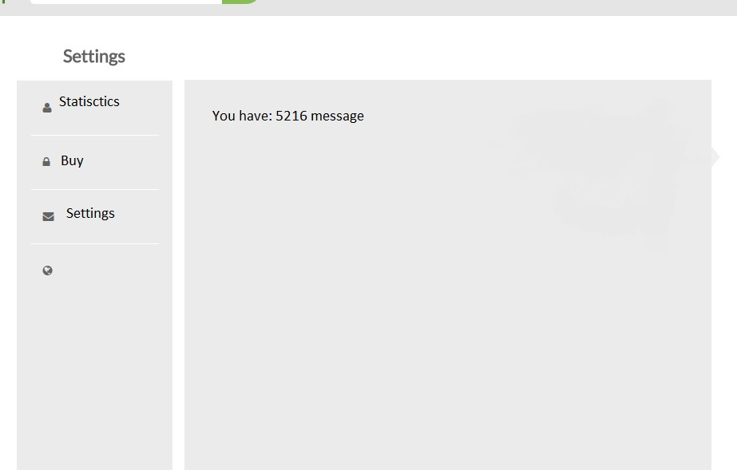

### SMS management: buy

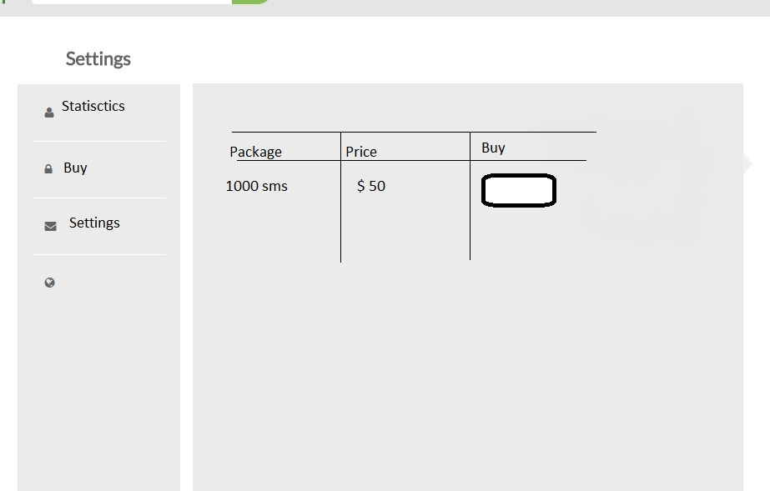

### SMS management: settings

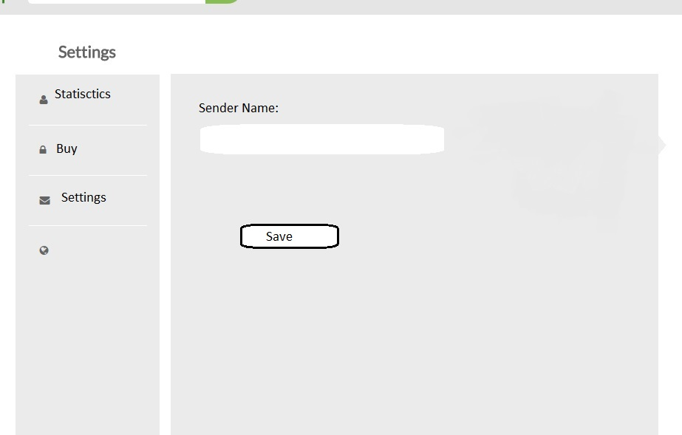

# Business Requirements Sign off

|  |  |  |  |  |
| --- | --- | --- | --- | --- |
| Name | Title | Entity | Date | Signature |
|  |  |  |  |  |
|  |  |  |  |  |
|  |  |  |  |  |
|  |  |  |  |  |